Divide-And-Conquer – Inversions

**Purpose**

This lab was designed to teach you how to use the divide and conquer problem solving paradigm by modifying an existing algorithm. Google collaborative filtering for further exploration.

**Description**

Calculate the number of inversions in an array in n log n time. The brute force algorithm has been provided which runs in O(n^2). The file has 100,000 integers arbitrarily ranging from 1 to 100,000 and no number is repeated. The maximum number of inversions is given by the formula (n*(n+1)) / 2.

Example: 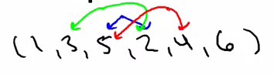

Inversions:(3,2), (5,2) and (5,4) or the number of pairs(i,j) of array indices with i<j and A[i] > A[j].

**Program Shell**

Create your own.

**Sample Execution**

Input:

90,40,20,30,10,67

3,15,61,11,7,9,2

// 3rd set from the input file

Output:

10 inversions

14 inversions

2407905288 inversions